Whatman Biometra TGRADIENT PCR 操作规程

一．Main menu
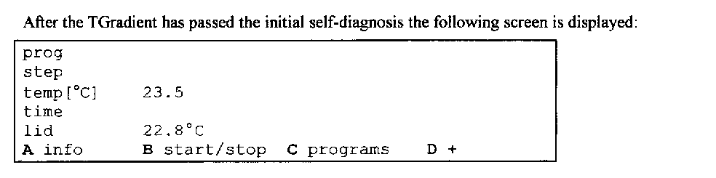
二．Create Program
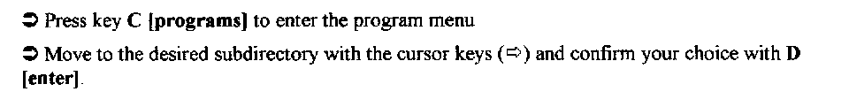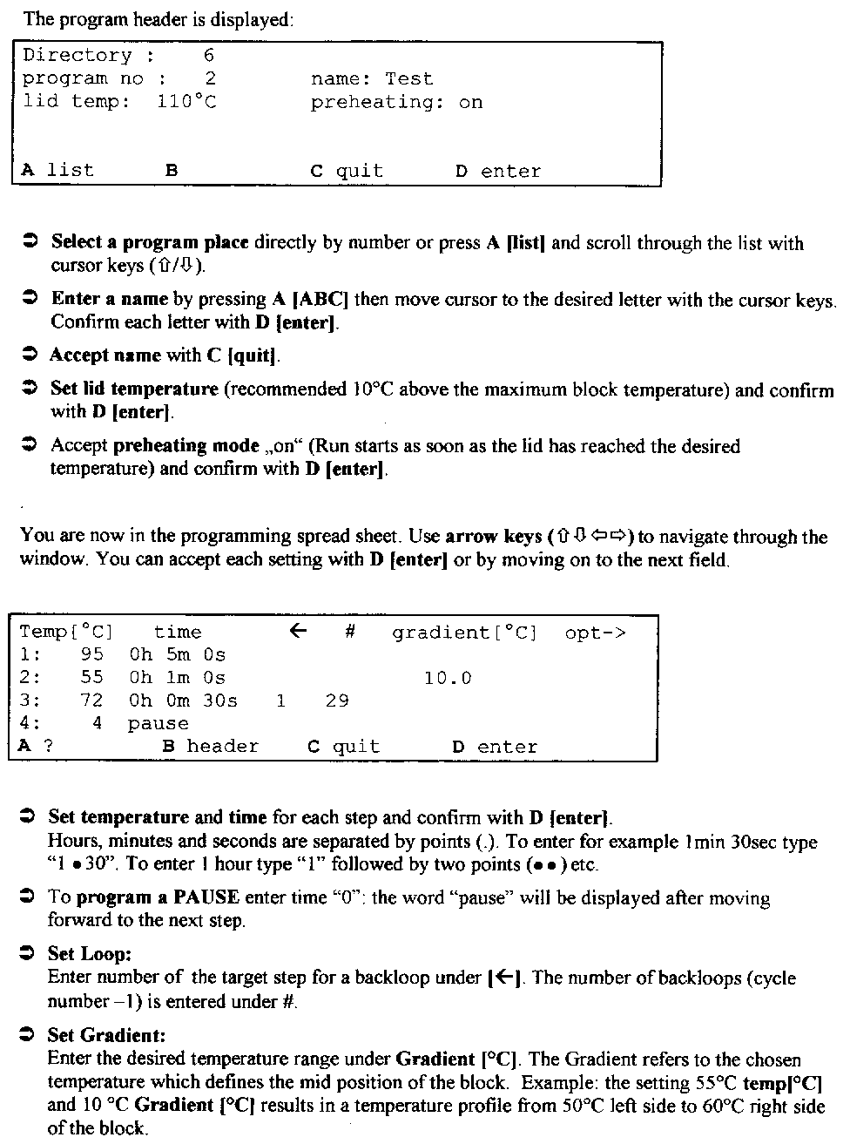
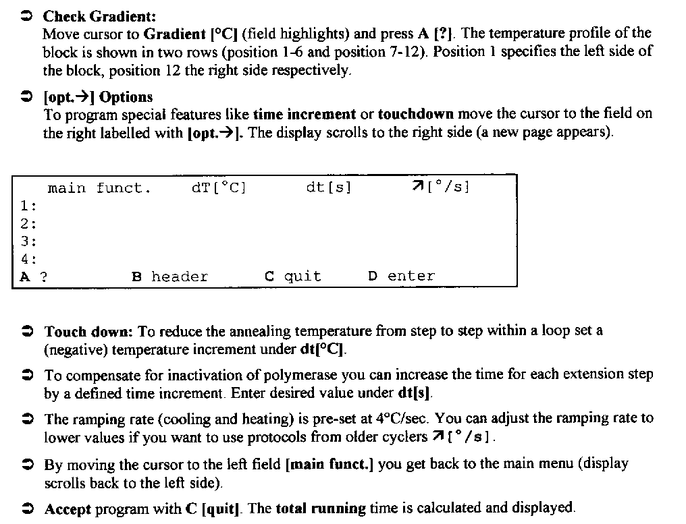

三．Select/Start Program
四．Display during operation
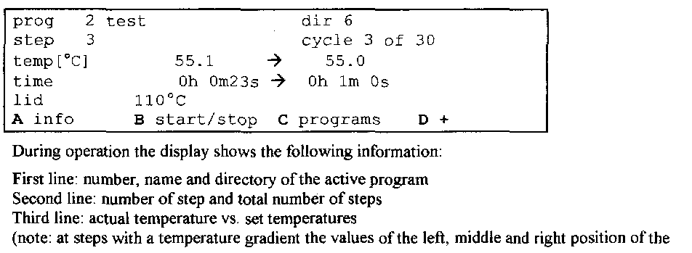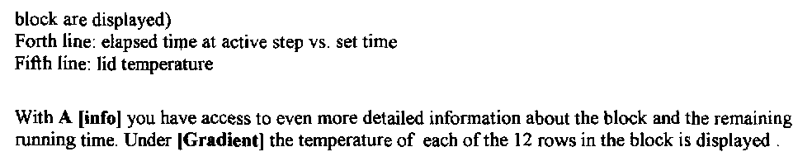
五．Stop/Pause Program
六．View active Program
